Allora Show
Miniature Goat Results
11th February 2023

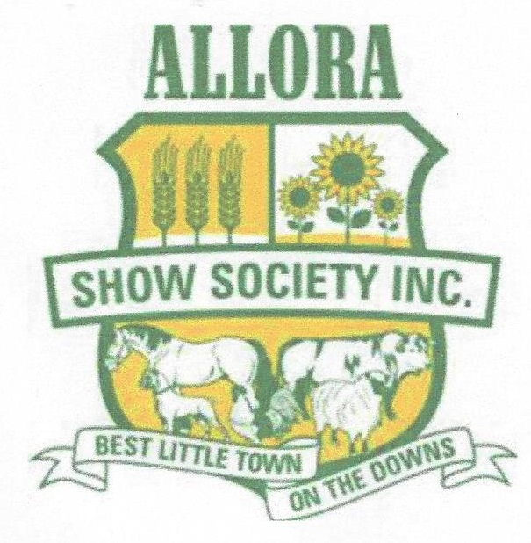

Judge – Jasmine Wilson

Time – 10.00am

Chief Steward – Therese Purton

Trophies donated by AABMGS Inc.

Garlands & Rosettes donated by – Lyndell Bentley - Wataview Stud & AAMBGS Inc.

CLASSES

1. Best Presented – Any Breed
1. Buccanwood Pickle – Rachael Chartres
2. Buccanwood Olive – Rachael Chartres

3. Junior Handler - Any Breed (Children 8 to 16 years)
1. Buccanwood Pickle – Madison Rayment
2. Buccanwood Olive – Savanah Peterson

WETHERS

6. Wether 0 to 6 months – Any Breed
1. Buccanwood Pickle – Rachael Chartres

Champion Miniature Kid Wether BUCCANWOOD PICKLE

8. Wether 1 to 2 years – Any Breed
1. Little Rock Bruno Mars – Rochelle Deenen

Champion Miniature adult Wether LITTLE ROCK BRUNO MARS

SUPREME MINIATURE WETHER BUCCANWOOD PICKLE

KID DOES UNDER 6 MONTHS:

11. AUSTRALIAN MINIATURE Kid Doe under 6 months
1. Buccanwood Olive – Rachael Chartres
2. Mya-Ora Verity – Allan & Therese Purton
3. Mya-Ora Jaria – Allan & Therese Purton

14. PYGMY Kid Doe under 6 months
1. Buccanwood Leilani – Claire Pearson
2. Mya-Ora Ellie-Mae – Lyndell Bentley
3. Little Rock Orianthi – Rochelle Deenen

CHAMPION KID DOE UNDER 6 MONTHS BUCCANWOOD LEILANI
RESERVE CHAMPION KID DOE UNDER 6 MONTHS MYA-ORA ELLIE-MAE

KID DOES 6 TO 12 MONTHS:

21. PYGMY Kid Doe under 12 months
1. Wildwood Destiny – Julie Foster
2. Tyalgum Ridge Cleo – Sandra Bell

CHAMPION KID DOE 6 TO 12 MONTHS WILDWOOD DESTINY
RESERVE CHAMPION KID DOE 6 TO 12 MONTHS TYALGUM RODGE CLEO

Junior Does 1 to 3 years:

24. MINIATURE ANGLO NUBIAN Junior Doe 1 to 3 years
1. Wildwood Zelda – Julie Foster

25. AUSTRALIAN MINIATURE Junior Doe 1 to 3 years
1. Buccanwood Armani – Claire Pearson
2. Buccanwood Alaska – Claire Pearson
3. Mya-Ora Ruby Moon – Allan & Therese Purton

26. ELF Junior Doe 1 to 3 years
1. Wildwood Blanche – Julie Foster

28. PYGMY Junior Doe 1 to 3 years
1. Buccanwood Nymeria – Claire Pearson
2. Wildwood Chloe – Julie Foster
3. Mya-Ora Effie – Lyndell Bentley

CHAMPION JUNIOR DOE WILDWOOD BLANCHE
RESERVE CHAMPION JUNIOR DOE BUCCANWOOD NYMERIA

ADULT DOES OVER 3 YEARS & OVER: (MUST HAVE KIDDED)

32. AUSTRALIAN MINIATURE Adult Doe over 3 years
1. Buccanwood Miss Dior – Claire Pearson

35. PYGMY Adult Doe over 3 years
1. Mini-Lee Caitlin Rose – Claire Pearson

CHAMPION ADULT DOE MINI-LEE CAITLIN ROSE
RESERVE CHAMPION ADULT DOE BUCCANWOOD MISS DIOR

KID BUCKS UNDER 6 MONTHS:

38. MINIATURE ANGLO NUBIAN Kid Buck under 6 months
1. Mya-Ora Sundance – Allan & Therese Purton
2. Mya-Ora Utah – Allan & Therese Purton
3. Mya-Ora Merlin – Allan & Therese Purton

39. AUSTRALIAN MINIATURE Kid Buck under 6 months
1. Mya-Ora Elliott – Allan & Therese Purton
2. Buccanwood Valentino – Claire Pearson
3. Mya-Ora Sir Lancelot – Claire Pearson

40. ELF Kid Buck under 6 months
1. Wildwood Diago – Julie Foster

42. PYGMY Kid Buck under 6 months
1. Petite Bleat Chance – Lyndell Bentley
2. Buccanwood Khal Drogo – Claire Pearson
3. Mya-Ora Rafael – Allan & Therese Purton

CHAMPION KID BUCK UNDER 6 MONTHS PETITE BLEAT CHANCE
RESERVE CHAMPION KID BUCK UNDER 6 MONTHS MYA-ORA SUNDANCE

KID BUCKS UNDER 12 MONTHS:

50. NIGERIAN DWARF Kid Buck 6 to 12 months
1. Colourful Eli-Maddox – Lyndell Bentley

CHAMPION KID BUCK 6 TO 12 MONTHS COLOURFUL ELI MADDOX

Junior BUCKS 1 to 3 years:

53. AUSTRALIAN MINIATURE Junior Buck 1 to 3 years
1. Mya-Ora Theodore Moon – Allan & Therese Purton

56. PYGMY Junior Buck 1 to 3 years
1. Narion Thomas – Sandra Bell
3. Narion Eskimo Joe – Rochelle Deenen
3. Mya-Ora Ed Sheeran – Rochelle Deenen

57. NIGERIAN DWARF Junior Buck 1 to 3 years
1. BDF Colten – Allan & Therese Purton

CHAMPION JUNIOR BUCK NARION THOMAS
RESERVE CHAMPION JUNIOR BUCK NARION ESKIMO JOE

ADULT BUCKS OVER 3 YEARS:

63. PYGMY Adult Buck over 3 years
1. Mya-Ora Sammy Davis – Lyndell Bentley
2. Mini-Lee Judas Priest – Julie Foster

CHAMPION ADULT BUCK MYA-ORA SAMMY DAVIS
RESERVE CHAMPION ADULT BUCK MINI-LEE JUDAS PRIEST

BEST OF BREED MINIATURE ANGLO NUBIAN
MYA-ORA SUNDANCE
ALLAN & THERESE PURTON

BEST OF BREED AUSTRALIAN MINIATURE
MYA-ORA ELLIOTT
ALLAN & THERESE PURTON

BEST OF BREED ELF GOAT
WILDWOOD BLANCHE
JULIE FOSTER

BEST OF BREED PYGMY
WILDWOOD DESTINY
JULIE FOSTER

BEST OF BREED NIGERIAN DWARF
COLOURFUL ELI MADDOX
LYNDELL BENTLEY & THERESE PURTON

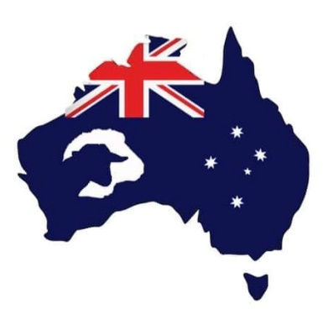

GRAND CHAMPION MINIATURE DOE
WILDWOOD BLANCHE
JULIE FOSTER
WILDWOOD STUD

GRAND CHAMPION MINIATURE BUCK
PETITE BLEAT CHANCE
LYNDELL BENTLEY & THERESE PURTON
WATAVIEW & MYA-ORA STUDS

SUPREME MINIATURE GOAT
WILDWOOD BLANCHE
JULIE FOSTER
WILDWOOD STUD

GRAND CHAMPION BABYDOLL SOUTHDOWN EWE
CAMARE CLOUD
JOHANNA WILLIANS

GRAND CHAMPION BABYDOLL SOUTHDOWN RAM
CAMARE MR MOPPET
JOHANNA WILLIANS

SUPREME MINIATURE SHEEP
CAMARE CLOUD
JOHANNA WILLIANS
CAMARE STUD

