Tenterfield Show
Miniature Goat Section
27/01/2024

Judge – Samantha Dulfer

Judging starts – 10:00am

Chief Steward – Rochelle Deenen

Trophies donated by AABMGS Inc.

Garlands & Rosettes donated by – Parklands Stud
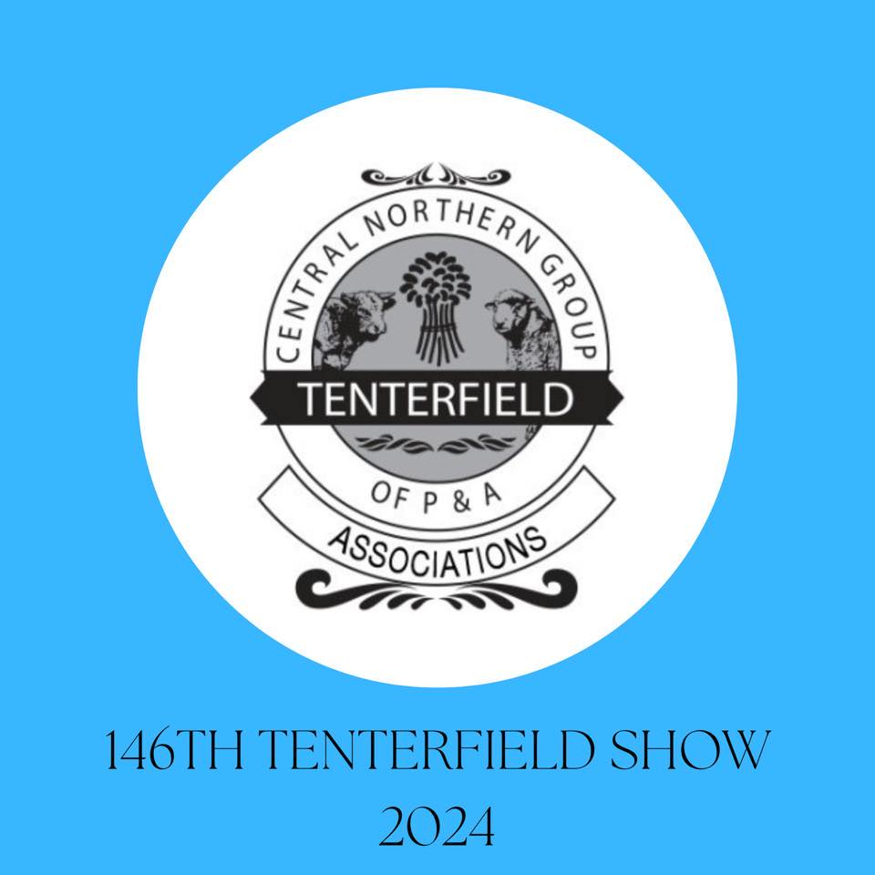

Prizes donated by the following Studs:
Little Rock
Mya-Ora
Wataview

CLASSES:
1. Best Presented – Any Breed
1. Honeybee Calliope – Tracey Filicietti
2. Gumnut Molly – Penelope Taylor

2. Kiddy Klass Handler - Any Breed (Children 7 years and under)
1. Clarivon Caprines Raven - Nash Arthur

3. Junior Handler - Any Breed (Children 8 to 16 years)
1. Gumnut Molly - Penelope Taylor

4. Adult Handler – Any Breed
1. Honeybee Caliope - Tracey Filicietti

5. Best Udder
1. Gumnut Molly - Penelope Taylor

WETHERS:

6. Wether Under 6 Months – Any Breed
1. Little Rock Prince - Rochelle Deenen
2. Little Rock Mr Bo Jangles - Rochelle Deenen

Champion Miniature Wether Under 6 Months
LITTLE ROCK pRINCE
Reserve Champion Miniature Wether UNDER 6 MONTHS
LITTLE ROCK MR BO JANGLES

9. Wether over 2 years - Any Breed
1. Little Rock Bruno Mars - Rochelle Deenen

Champion Miniature adult Wether
LITTLE ROCK BRUNO MARS
Reserve Champion Miniature adult Wether

SUPREME MINIATURE WETHER
LITTLE ROCK BRUNO MARS

KID DOES UNDER 6 MONTHS:

10. MINIATURE ANGLO NUBIAN Kid Doe under 6 months
1. Wildwood Evangelista - Liam Holland
2. Clarivon Caprines Winnie - Sue Smith
3. Clarivon Caprines Zoya - Sue Smith

11. AUSTRALIAN MINIATURE Kid Doe under 6 months
1. KaiDi Park Tianna - Kristy Gillman
2. Benclue Hailey - Tracey Filicietti

12. ELF Kid Doe under 6 months
1. Pippinwood Freya - Kristy Gillman

14. PYGMY Kid Doe under 6 months
1. Little Rock My Sharona - Rochelle Deenen
2. Little Rock Cecilia - Rochelle Deenen
3. Little Rock Reba McEntire - Rochelle Deenen

15. NIGERIAN DWARF Kid Doe under 6 months
1. Wataview Mimi - Lyndell Bentley

16. MINIATURE BOAR Kid Doe under 6 months
1. KaiDi Park Ilianna - Kristy Gillman

CHAMPION KID DOE UNDER 6 MONTHS
WILDWOOD EVANGELISTA
RESERVE CHAMPION KID DOE UNDER 6 MONTHS
LITTLE ROCK MY SHARONA

KID DOES 6 TO 12 MONTHS:

17. MINIATURE ANGLO NUBIAN Kid Doe under 12 months
1. Clarivon Caprines Maple - Sue Smith

CHAMPION KID DOE 6 TO 12 MONTHS
CLARIVON CAPRINES MAPLE
RESERVE CHAMPION KID DOE 6 TO 12 MONTHS

Junior Does 1 to 3 years:

25. AUSTRALIAN MINIATURE Junior Doe 1 to 3 years
1. Wataview Marisol - Lyndell Bentley
2. Honeybee Calliope - Tracey Filicietti

28. PYGMY Junior Doe 1 to 3 years
1. Wildwood Destiny - Liam Holland

30. MINIATURE BOAR Junior Doe 1 to 3 years
1. Pippinwood Angel - Kristy Gillman

CHAMPION JUNIOR DOE
WATAVIEW MARISOL
RESERVE CHAMPION JUNIOR DOE
HONEYBEE CALLIOPE

ADULT DOES OVER 3 YEARS & OVER: (MUST HAVE KIDDED)

32. AUSTRALIAN MINIATURE Adult Doe over 3 years
1. Buccanwood Armani - Lyndell Bentley
2. Gumnut Molly - Penelope Taylor

CHAMPION ADULT DOE
BUCCANWOOD ARMANI
RESERVE CHAMPION ADULT DOE
GUMNUT MOLLY

KID BUCKS UNDER 6 MONTHS:

38. MINIATURE ANGLO NUBIAN Buck Kid under 6 months
1. Wildwood Elorado - Liam Holland

39. AUSTRALIAN MINIATURE Buck Kid Under 6 mobths
1. Benclue Hurricane - Tracey Filicietti
2. KaiDi Park Beau - Kristy Gillman

42. PYGMY Kid Buck under 6 months
1. Kidiwink Kidz Osian - Lyndell Bentley
2. Litle Rock Jimmy Ricard - Rochelle Deenen
3. Petite Bleat Van Halen - Rochelle Deenen

CHAMPION KID BUCK UNDER 6 MONTHS
KIDIWINK KIDZ OSIAN
RESERVE CHAMPION KID BUCK UNDER 6 MONTHS
BENCLUE HURRICANE

KID BUCKS UNDER 12 MONTHS:
Junior BUCKS 1 to 3 years:

54. ELF Junior Buck 1 to 3 years
1. Wildwood Diego - Liam Holland

56. PYGMY Junior Buck 1 to 3 years
1. Petite Bleat Chance - Lyndell Bentley
2. Narion Eskimo Joe - Rochelle Deenen

CHAMPION JUNIOR BUCK
PETITE BLEAT CHANCE
RESERVE CHAMPION JUNIOR BUCK
NARION ESKIMO JOE

ADULT BUCKS OVER 3 years:

63. PYGMY Adult Buck over 3 years
1. Mya-Ora Ed Sheeran - Rochelle Deenen
2. Mini-Lee Judas Priest - Liam Holland

CHAMPION ADULT BUCK
MYA-ORA ED SHEERAN
RESERVE CHAMPION ADULT BUCK
MINI LEE JUDAS PRIEST

66. Sire or Dam & 1 Progeny
1. Mya-Ora Ed Sheeran & Little Rock Reba McEntire - Rochelle Deenen
2. Pippinwood Angel & KaiDi Park Ilianna - Kristy Gillman

68. Breeders Pair
1. KaiDi Park ilianna & KaiDi Park Levi - Kristy Gillman
2. KaiDi Park Tinna & KaiDi Park Beau - Kristy Gillman

Best Of Breed:
MINIATURE ANGLO NUBIAN Wildwood Evangelista
AUSTRALIAN MINIATURE KaiDi Park Tinana
ELF GOAT Wildwood Diego
PYGMY Kidiwink Kidz Osian
MINIATURE BOAR Pippinwood Angel

GRAND CHAMPION DOE
WILDWOOD EVANGELISTA
LIAM HOLLAND

GRAND CHAMPION BUCK
KIDIWINK KIDZ OSIAN
LYNDELL BENTLEY

SUPREME MINIATURE GOAT
WILDWOOD EVANGELISTA
LIAM HOLLAND

